**About the company :**

**Its an Australian entrepreneurial endeavour.**

**Mission and vision of the company :**

**Creating a different world of learning together for everyone beyond all barriers and boundaries.**

Nothing much to talk about this slide. We can read out and say “how awesome is the mission and vision statement of the company.

1. Teachers will be uploading videos as per their desired subjects of a particular class/syllabus/Board and upload the test papers also at the end of the video as word files.
2. 2.Students can ask questions in a common area as a blog and teachers can answer them so that in future any other student have the same query can get the reference from there. In this process there will be a pool of question answers in the blogging area from where students can search their desired answers.
3. Teachers can give feedback to their individual students and grade them after checking their test papers and can be.
4. Students can study any time they choose to. No conflict with time matching.
5. Students can study at their own pace. There will not be any time limit for finishing the course thus no additional pressure will be created to the student.
6. Students can ask questions in the blogging area and can see other question answers also if needed.
7. Study can be done anywhere even without internet . It can be good for the mental health of the student if he/she can study in the open air or anywhere they like to with any device like Laptop/Smart phone/ Tab/ipad etc.
8. 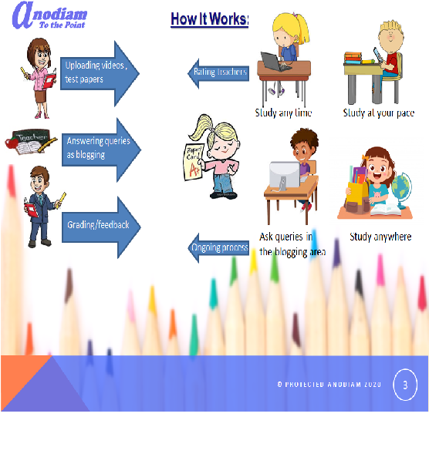

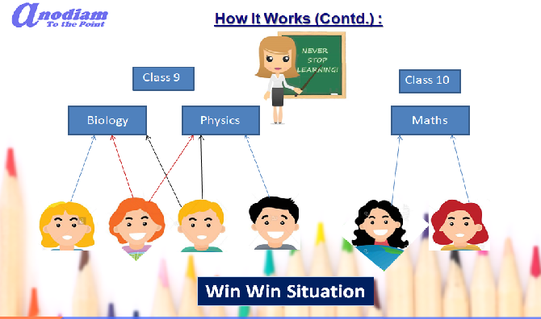

1. A teacher can upload videos of one or more subjects/classes/syllabus/board
2. Students can buy one or more subjects from one or many teachers. E.g One student can buy a biology course from more than one teacher. A class 9 student can buy class 10 maths also if they want to do so.
3. This process can be repeated over and over with a video uploaded once.
4. Teachers will get more and more students buying the same video again and again and students will also get options to choose thus creating a win win situation.

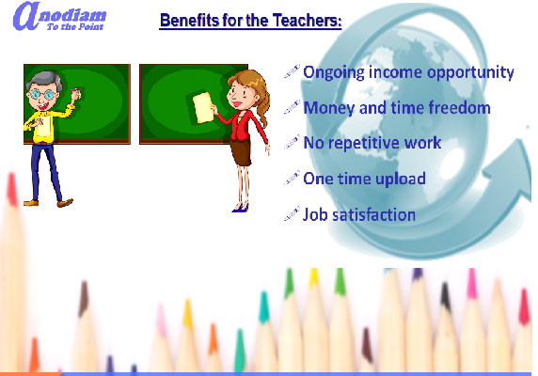

1. You will have ongoing income opportunity with time.
2. Don’t have to repeat the same work again and again and this way you have spare time for yourself.
3. You can create your best videos to upload so that students can get all the benefits out of it and can refer your name to their friends making you popular for a work which is not repetitive. For the best word of mouth a teacher needs to spend so many months / years to teach in one subject over and over but here once your video is published you have ample opportunity to reach among many students anywhere, anytime.
4. Once you record your best video and upload it in our website your work is done. In this way you can deliver your best and get more job satisfaction.